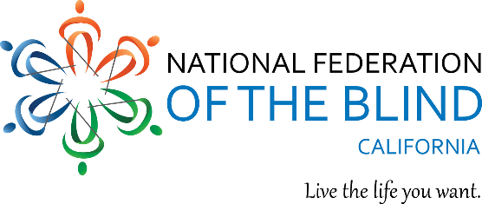

Welcome to the 2024 National Federation of the Blind of California State Convention

Sunday March 17, 2024

Impact: Touching Our World with Hope and Determination

The National Federation of the Blind knows that blindness is not the characteristic that defines you or your future. Every day we raise the expectations of blind people because low expectations create obstacles between blind people and our dreams. You can live the life you want; blindness is not what holds you back. Together with love, hope, and determination, we transform dreams into reality.

9:00 am – 12:00 pm General Session III, California Ballroom

9:00 am Our Money—Financial Report
Affiliate Treasurer Tiffany Manosh reports on our financial state.

9:15 am Hand IN Hand—A Report from Your President
The President of the National Federation of the Blind of California provides an update on the activities of the affiliate over the past year, the financial state of the organization and reflections for the future.

9:40 am Resolutions
The convention votes on the proposed resolutions.

10:30 am Election of Officers & Board Members
An election will be run for the open positions including any nominations from the floor and short statements from the candidates.

12:00 pm Adjourn and shuttle van boarding.

Thank You to Our Convention Committees and Coordinators
Every year, too many individuals to name donate their time and talents to make our convention amazing. We operate this convention with a primarily volunteer team. We would love to have more people join our stellar group for convention planning and logistics efforts. Please share your desire to join us next year with president@nfbcal.org and Rachel Grider (rachel.grider@gmail.com), or call (916) 382-0372.

Thank you to the below leaders who graciously donated their time and abilities.

Scholarships: Lisamaria Martinez, Skyler Covich and Gene Kim
Resolutions: Co-Chairs Ever Lee Hairston, Bryan Bashin, members Cricket Bidleman, Shannon Dillon, Tim Elder, Rachel Grider, and Jamie Principato Crane
Nominations: Chairperson Ever Hairston, and unconflicted chapter representatives Jacquisse Braxton, Cathy Gaten, Veronica Martinez, Jeanette Jones, Yvette Lee, Michael Richardson, Cheryl Thurston, Arietta Woods, Marisa Vallejo, Brooklyn Kelly, Carmen Weatherly, Julia Cardenas, Joy Stigile, Bobbi Pompey, Miguel Mendez, Kyle Garcia, and Debbie Worstman
Transportation: Cheryl Thurston
Registration: Tiffany Manosh, Robert Stigile and Shannon Dillon
Exhibits: Cheryl Thurston
Banquet: Rachel Grider
Parents: Jeanette Jones
Spanish Translation and Closed-Captioning: Carmen Varela and Rachel Grider
Agenda Embossing and Printing: Brian Buhrow and Tiffany Manosh
Audio Video: Brian Buhrow
Ambassador: Michael Richardson
Rookies: Cheryl Thurston, Veronica Martinez, and Jamie Principato Crane
Door Prizes: Tiffany Manosh & Angela Fowler
Auction Baskets: Karen Steele and Michael Richardson
Guide Dog Relief: Shannon Dillon
PAC: Robert Stigile

