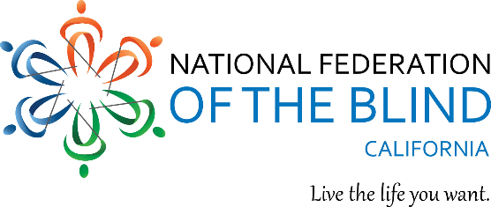

Welcome to the 2024 National Federation of the Blind of California State Convention

Thursday March 14, 2024

Impact: Touching Our World with Hope and Determination

The National Federation of the Blind knows that blindness is not the characteristic that defines you or your future. Every day we raise the expectations of blind people because low expectations create obstacles between blind people and our dreams. You can live the life you want; blindness is not what holds you back. Together with love, hope, and determination, we transform dreams into reality.

6:00 pm - 7:00 pm Board Meeting
President Tim Elder
Meetings of the Board of Directors are open to the public. Please join us as we discuss hybrid voting and nominations policies, greet our scholarship finalists and hear from National Federation of the Blind, National Representative Norma Crosby. All first timers should attend. We will recognize rookies at the end of the board meeting.
California Ballroom

7:30 pm - 9:00 pm Diabetes Action Network
President Joy Stigile
Our speaker this year is Andrea Milton, a Certified Diabetes Dietician Educator. She will give information about food amounts, ideas on how to keep in better control of your blood sugar levels, differences between type one and type two Diabetes, the 2 main Continuous Blood Glucose Monitors available and different snack ideas.
When you are a paid member of DAN of California it will allow you to vote, hold office, and make motions. Dues are $10. All our welcomed to attend and learn more about Diabetes!
California Ballroom

